St. Theresa of Lisieux-St. Theresa, the Little Flower.

Who was St. Theresa?
Saint Theresa of Lisieux is the Patron Saint of our school and Parish. She was born on January 2nd 1873 and was the youngest child born to Louis and Zelie Martin. They had nine children altogether, but only 5 lived to be adults. Sadly, Theresa’s mother Zelie died when Theresa was only 4 years old. As a child Theresa was quite difficult, she had a determined nature and would get frustrated and angry if she couldn’t have her own way – just like many children can be from time to time! Both her parents described her as being independent and wilful even at a young age.
When she was 14 years old on Christmas Eve in 1886 a strange thing happened to Theresa, she suddenly felt very close to God and decided to devote all of the rest of her life to him. This is called a Conversion. She decided from that moment on she would stop being selfish and demanding and turn all her energy into love for God.
When she was 15 she was allowed, after lots of prayer and requests, to join a convent to become a religious sister or nun. In the Convent she felt at peace and took the name Sister Therese of the Child Jesus and the Holy Face.
She lived a very simple life in the Convent, she prayed deeply and carried out simple tasks. She said that doing something simple even as little as picking up a pin could be an act of love for God. She was content in the Convent and kept a very close relationship with God, through prayer, even though she was often ill or weak.
Eventually, she died at the young age of 24 – she had Tuberculosis, in those days there was no cure for this illness. When Theresa was very ill she realised that she was dying and said that when she died she would send down blessings to earth like flowers from Heaven. Many people have prayed to her for miracles and their prayers have been answered. The last words she spoke as she died were ‘My God I love you.’
Theresa was made a Saint by Pope Pius XI in 1925.
St. Theresa’s Feast Day is on October 1st every year.

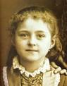
This is a picture of Therese Martin as a child, it is taken from a family photograph with her sister; you can see her sister’s hand on her shoulder in the picture.
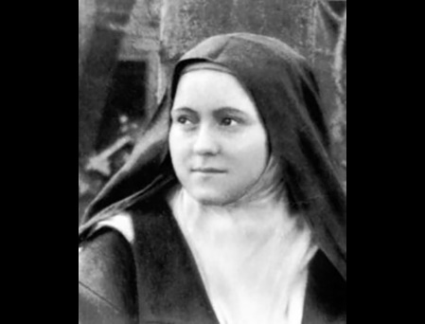
This is a picture of St. Theresa, when she had joined the Convent; you can see that she is wearing the traditional clothing of a religious sister.
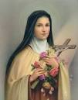
This is the traditional image we have of St. Theresa, as a saint. In this image we can see her in her Convent clothing again. Now she is holding the crucifix with Jesus on it and beautiful flowers. She is often called ‘St. Theresa, the Little Flower’, to remind us that she promised to send down blessings to earth from Heaven like flowers from Heaven.

