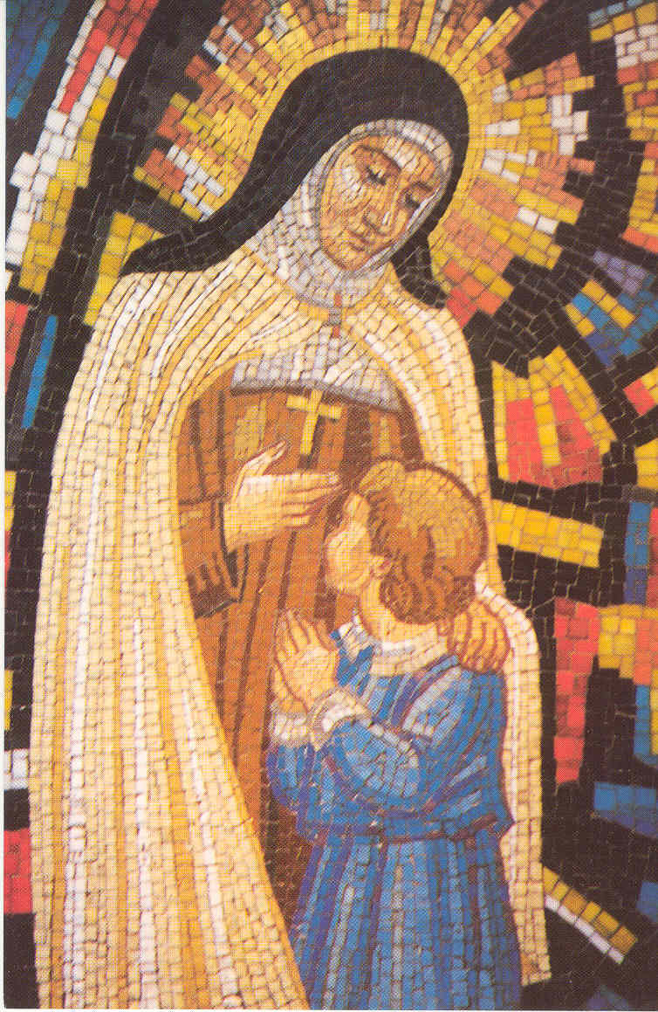
St Theresa’s Catholic Primary School
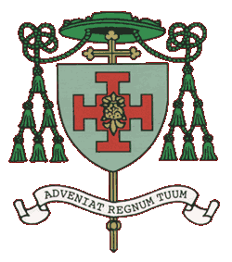
Kipling Road,
Blacon,
Chester.
CH1 5UU

Telephone: 01244 470860

Diocese of Shrewsbury

Fully valuing everyone
in the love of Jesus. Headteacher: Mrs N Kirkman.

Caring and Learning Together

30 HOURS FREE CHILDCARE

Dear Parents and Carers,

The Government offer 30 hours free childcare to families who are eligible.

You may be eligible if your family meet the following:

- both parents are working (or the sole parent is working in a lone parent family) AND
- each parent earns, on average, a weekly minimum equivalent to 16 hours at national minimum wage or national living wage, OR
- one or both parents is either on maternity/paternity or adoption leave; or where one parent has substantial caring responsibilities and is in receipt of carers allowance, or where one parent is employed and one is disabled or incapacitated based on receipt of specific benefits.

If you feel you are eligible please ask for a registration form from the School Office.

Yours sincerely,

Mrs Simcott
Bursar



