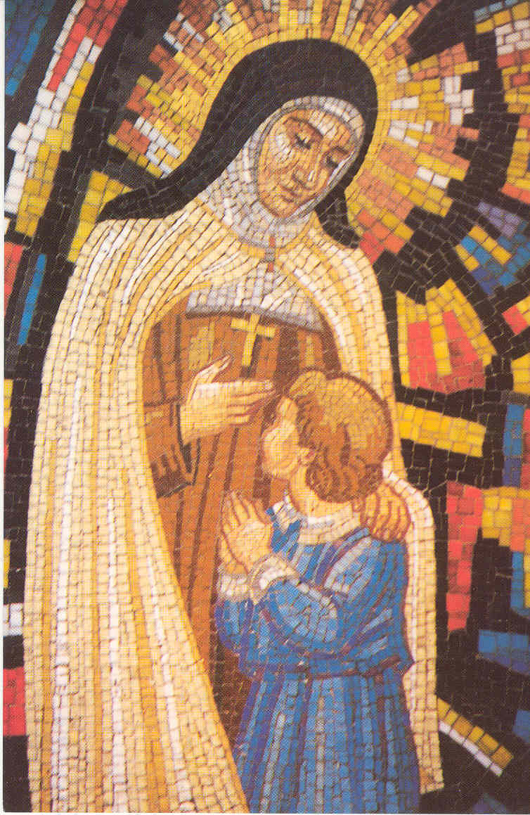
St Theresa’s Catholic Primary School
Kipling Road
Blacon
Chester
CH1 5UU

Telephone: 01244 981070

Headteacher: Mrs N Kirkman

BURWARDSLEY OUTDOOR EDUCATION CENTRE VISIT
29th and 30th April

Dear Parent or Carer,

We are once again taking the Year 2 children to Burwardsley for an overnight stay. The children enjoy long walks, develop map skills, enjoy activities using their Forest School skills, seeing wild life and enjoying a night together away from home. They will also visit the Candle Factory. The evening meal, supper, breakfast and lunch on both days is provided.

This visit requires a voluntary donation of £55.00 per child. This has been subsidised by school and covers the cost of the stay, activities, insurance and transport. An initial non-refundable deposit of £20.00 is due by Friday 6th March. The full amount of £55.00 must be paid by Friday 17th April in order for us to pay for your child’s place. This year please pay online via ParentPay. If you have any queries regarding payments, please do not hesitate to contact us. Regular payments are welcome and will be recorded at the school office.

If you wish to visit the Burwardsley Website for more information, please click on the link on our Website.
www.st-theresas.cheshire.sch.uk

If we do not receive the voluntary donation from all families, the trip will not be able to take place.

Yours sincerely,

Mrs McConnell
Year 2 Class Teacher

Required payment dates:
By Friday 6th March: Non-refundable Deposit of £20
By Friday 20th March: £20
By Friday 17th April: £15

